EXPERIMENT 4 — UPDATE and DELETE
AIM:
To perform UPDATE and DELETE operations on records in the AutoHub Showroom database.
PROCEDURE:
- Select the AUTOHUB_SHOWROOM database.
- Update the price of a vehicle.
- Update the fuel type of a vehicle.
- Update a customer's name.
- Update the city of a showroom branch.
- Delete a vehicle record.
- Delete a customer record.
- Delete a showroom branch record.
- Use SELECT statements to verify the changes.
OUT: 1
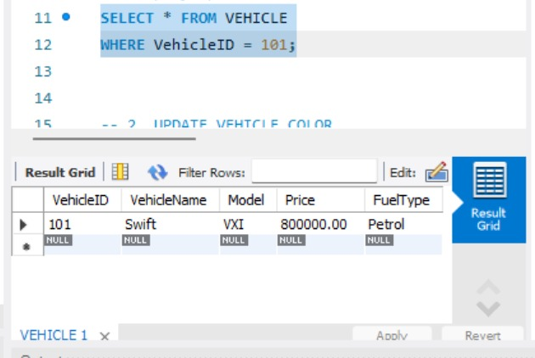
OUT: 2
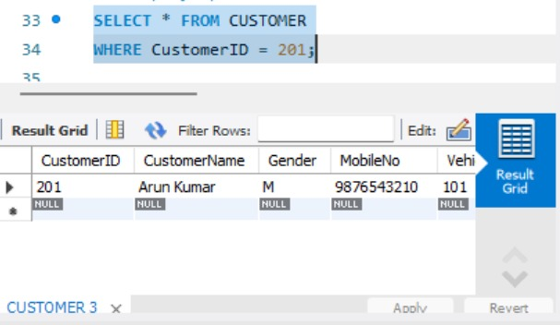
OUT: 3
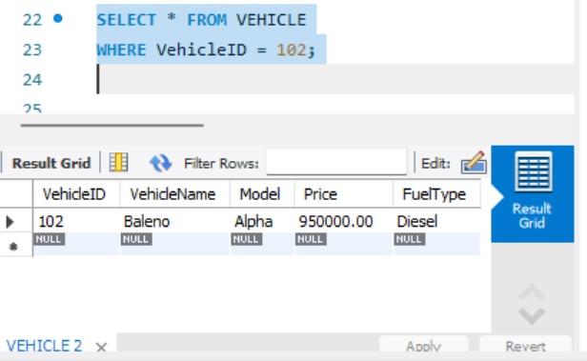
OUT: 4
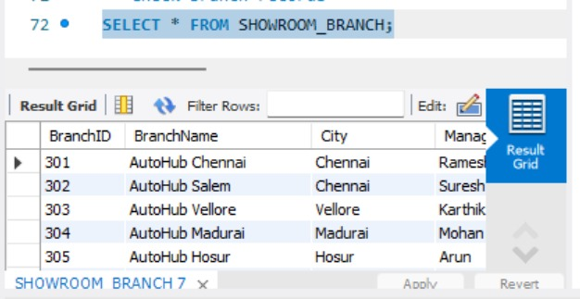
OUT: 5
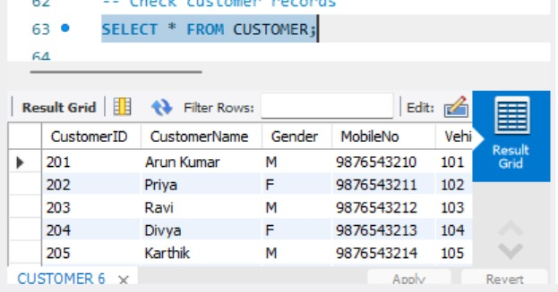
OUT : 6
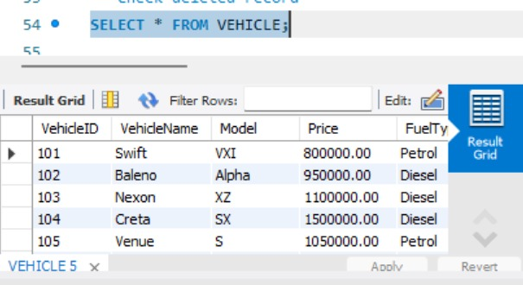
OUT : 7
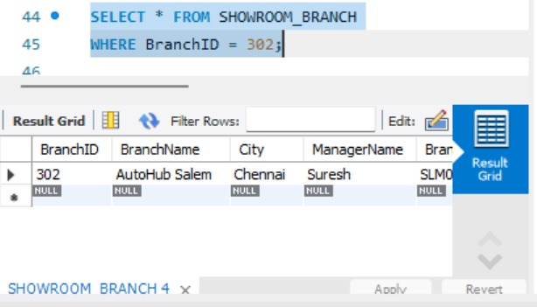
QUERY:
USE AUTOHUB_SHOWROOM;
-- 1. UPDATE VEHICLE PRICE
UPDATE VEHICLE
SET Price = 800000
WHERE VehicleID = 101;
-- Display updated record
SELECT * FROM VEHICLE
WHERE VehicleID = 101;
-- 2. UPDATE VEHICLE COLOR
UPDATE VEHICLE
SET FuelType = 'Diesel'
WHERE VehicleID = 102;
-- Display updated record
SELECT * FROM VEHICLE
WHERE VehicleID = 102;
-- 3. UPDATE CUSTOMER CITY
UPDATE CUSTOMER
SET CustomerName = 'Arun Kumar'
WHERE CustomerID = 201;
-- Display updated customer
SELECT * FROM CUSTOMER
WHERE CustomerID = 201;
-- 4. UPDATE SHOWROOM BRANCH
UPDATE SHOWROOM_BRANCH
SET City = 'Chennai'
WHERE BranchID = 302;
-- Display updated branch
SELECT * FROM SHOWROOM_BRANCH
WHERE BranchID = 302;
-- 5. DELETE A VEHICLE RECORD
DELETE FROM VEHICLE
WHERE VehicleID = 108;
-- Check deleted record
SELECT * FROM VEHICLE;
-- 6. DELETE A CUSTOMER RECORDDELETE FROM CUSTOMER
WHERE CustomerID = 208;
-- Check customer records
SELECT * FROM CUSTOMER;
-- 7. DELETE A SHOWROOM BRANCH RECORD
DELETE FROM SHOWROOM_BRANCH
WHERE BranchID = 308;
-- Check branch records
SELECT * FROM SHOWROOM_BRANCH;
RESULT:
Thus, the UPDATE and DELETE operations were successfully performed and the modified records were verified.

